create or replace procedure p_dept is

p_dept_id departments.departmentid%type;

p_dept_name departments.departmentname%type;

begin

p_dept_id:=8;

p_dept_name:='Computer science';

insert into departments(departmentid,departmentname)

values(p_dept_id,p_dept_name);

end;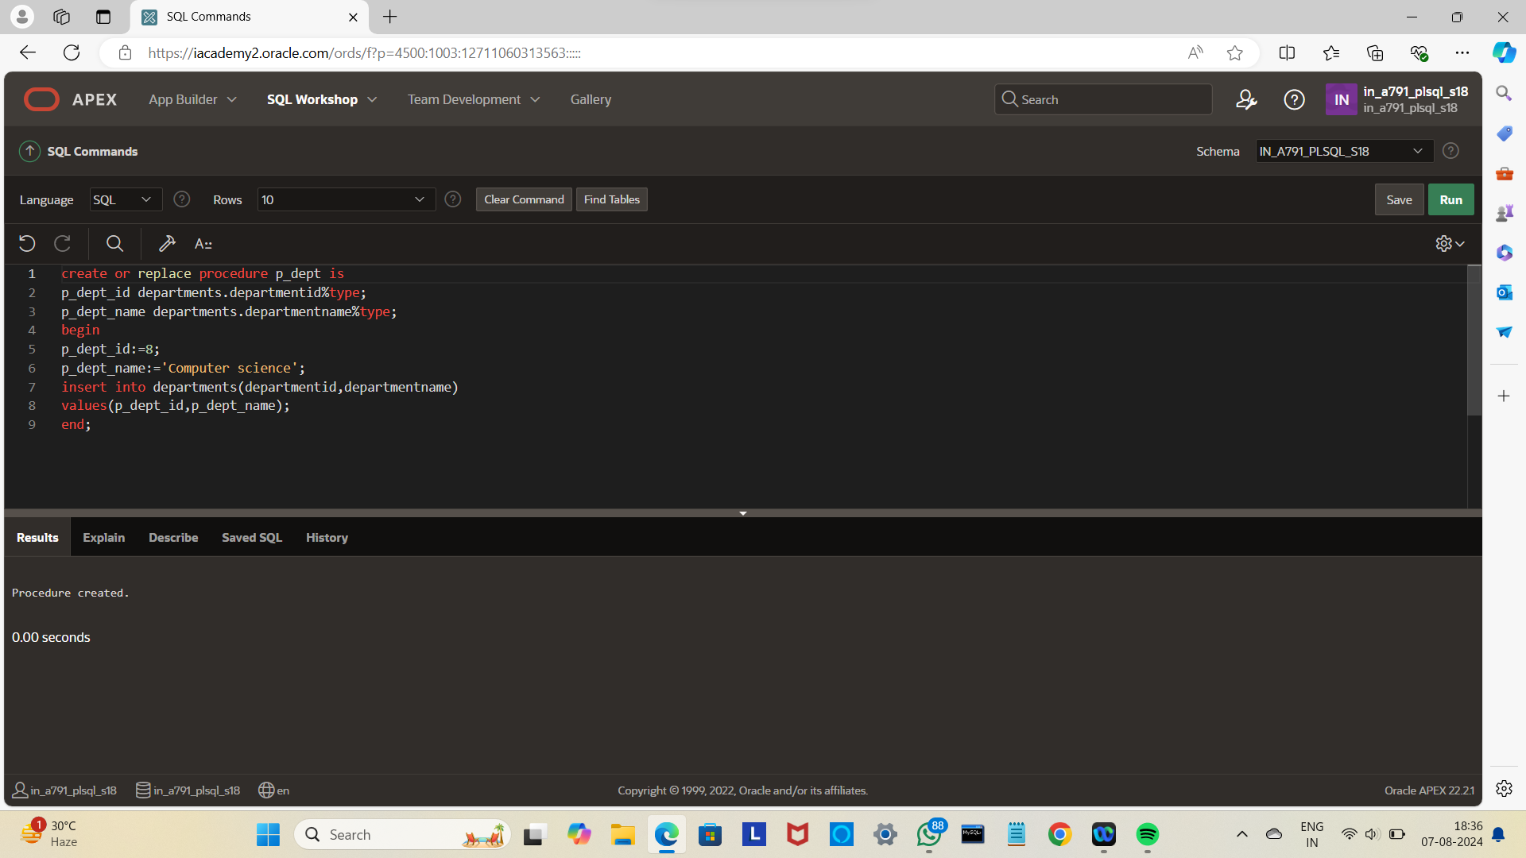

begin

p_dept ;

end;

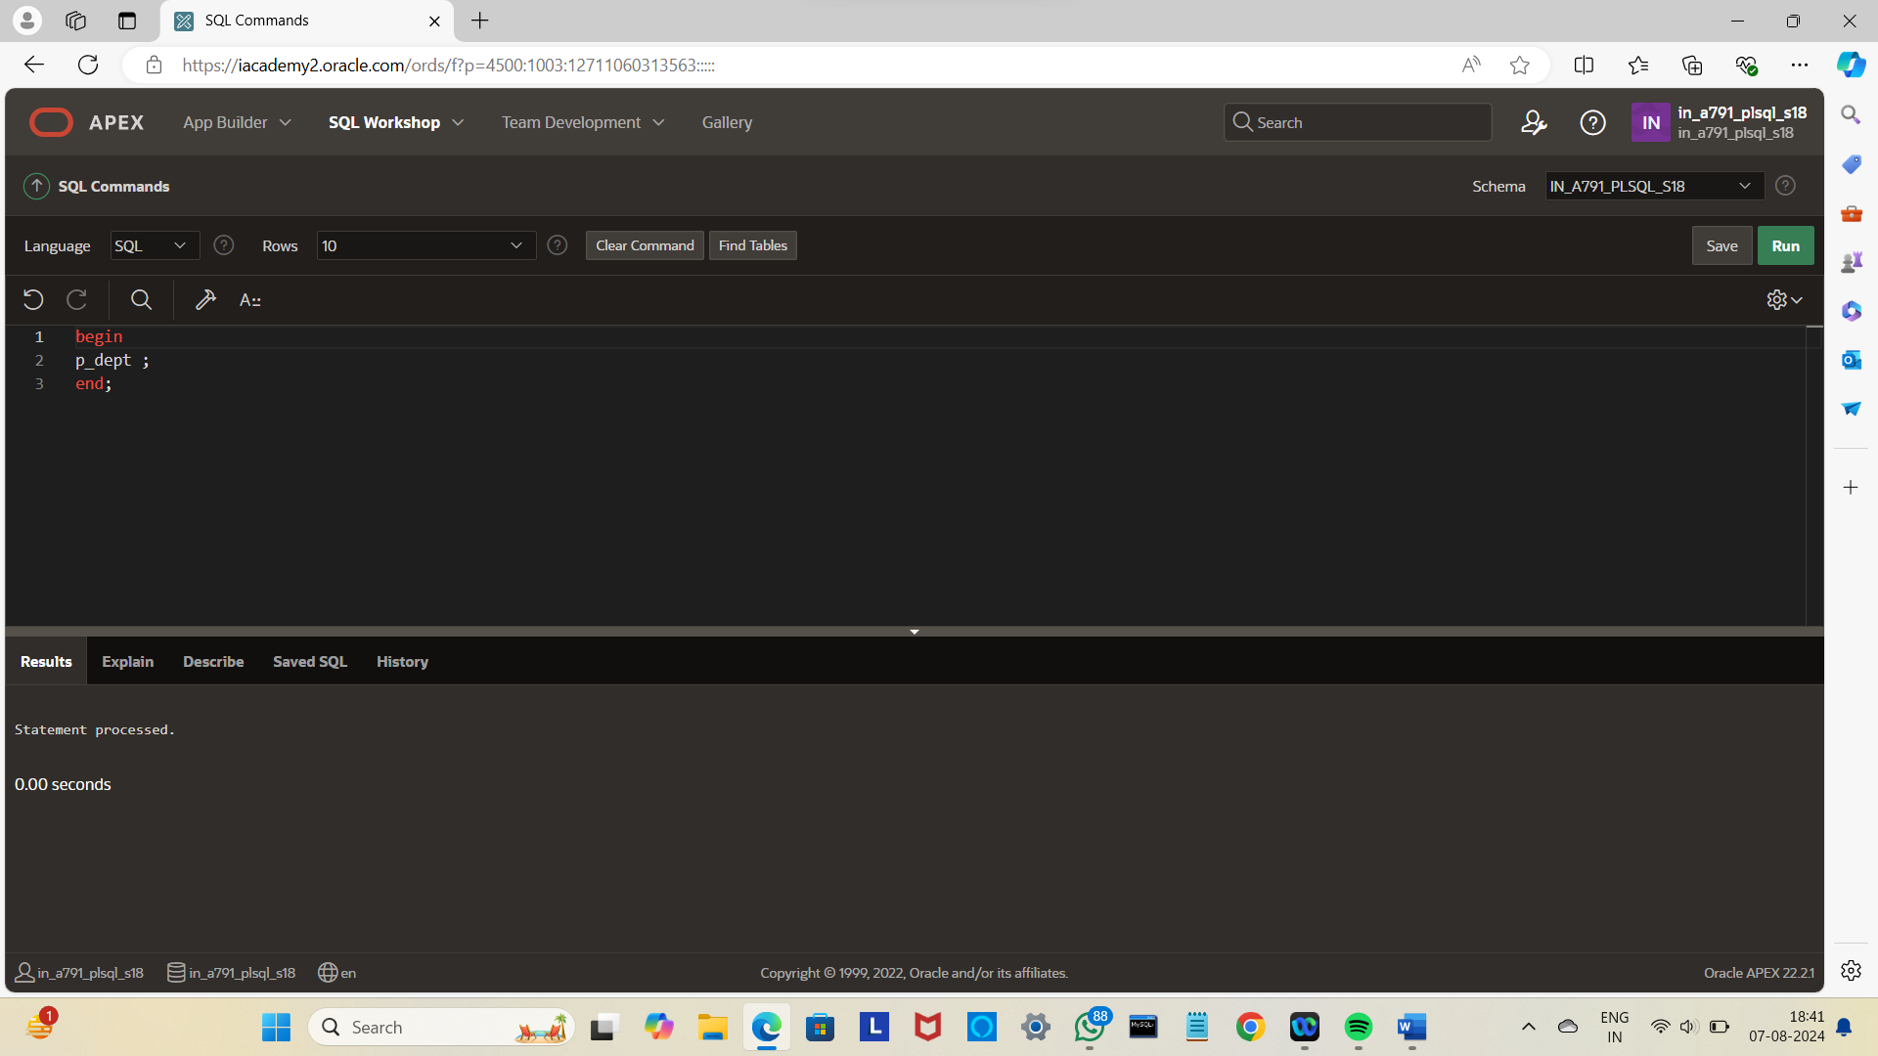

Select*from departments;

